**Whole Devops Flow**

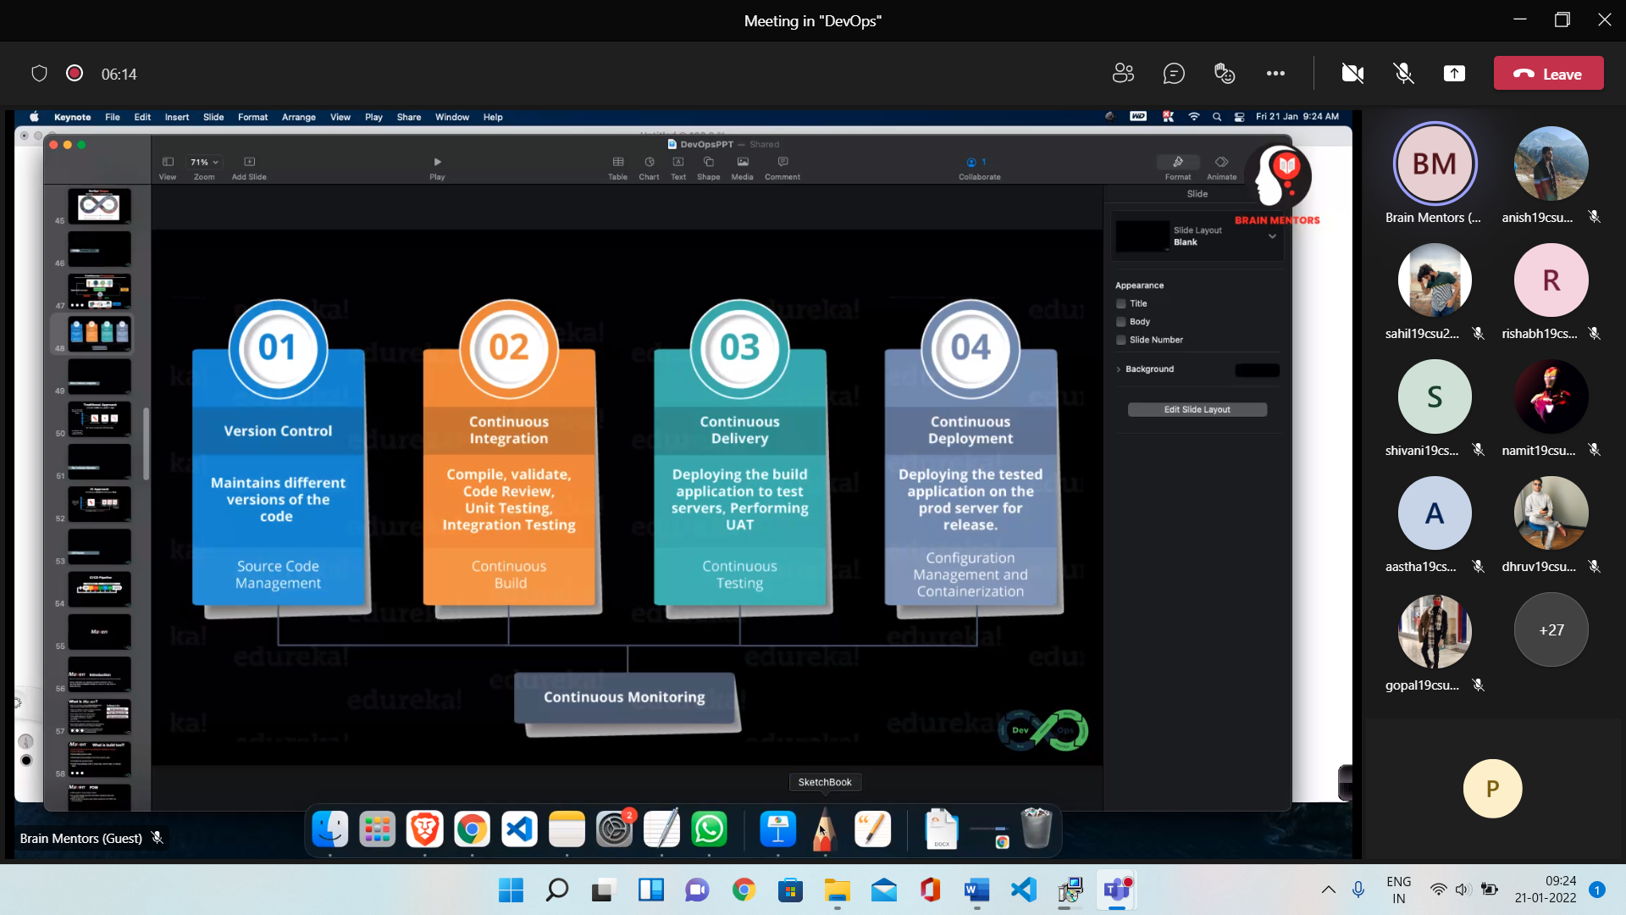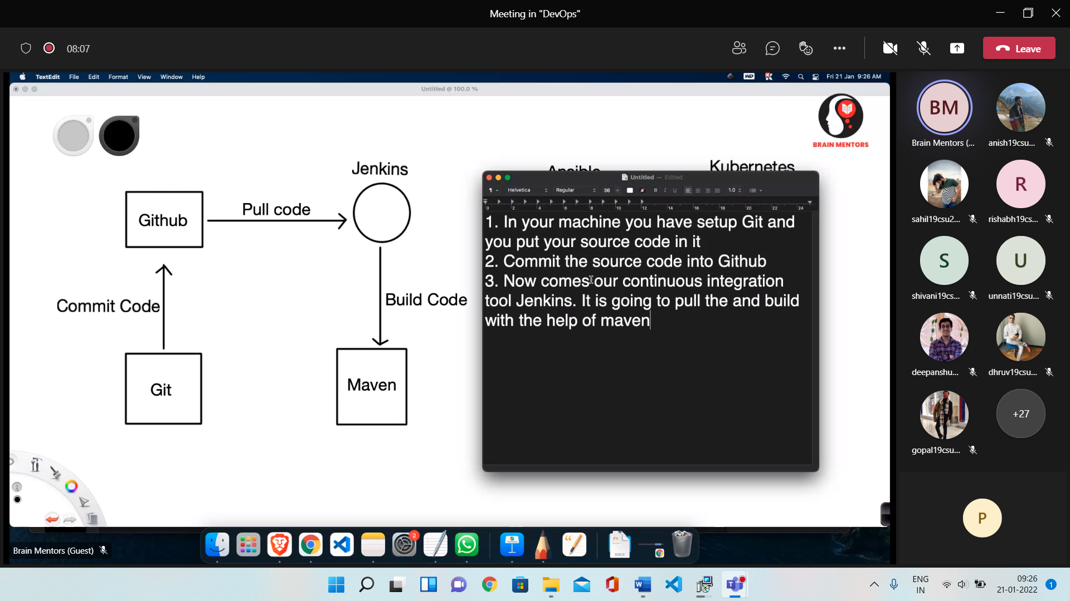

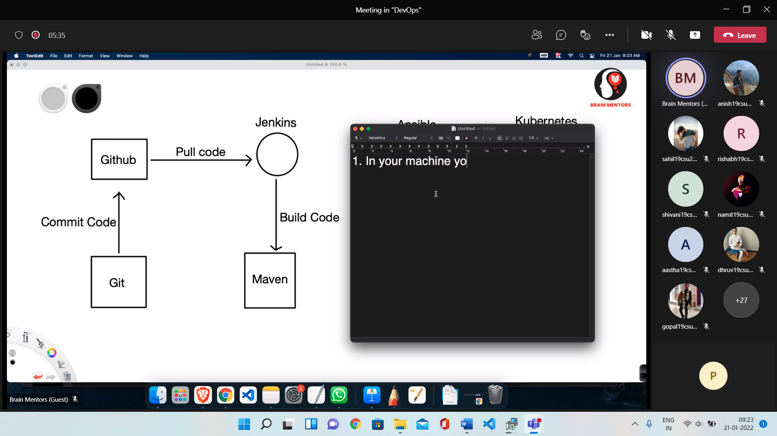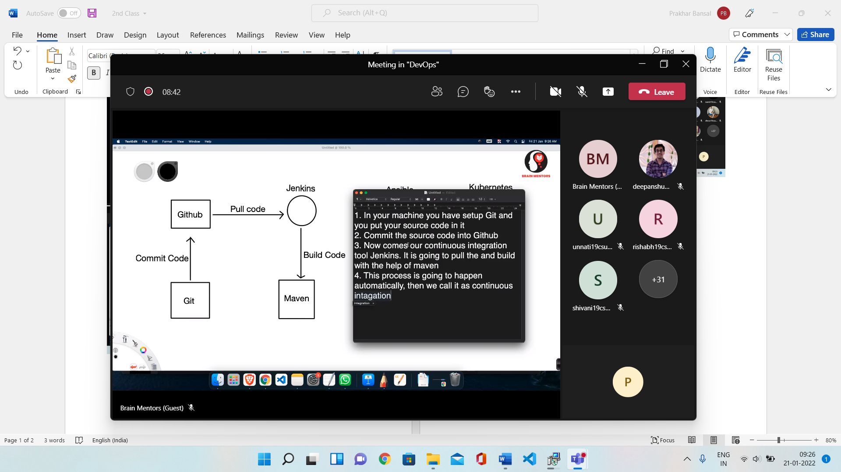

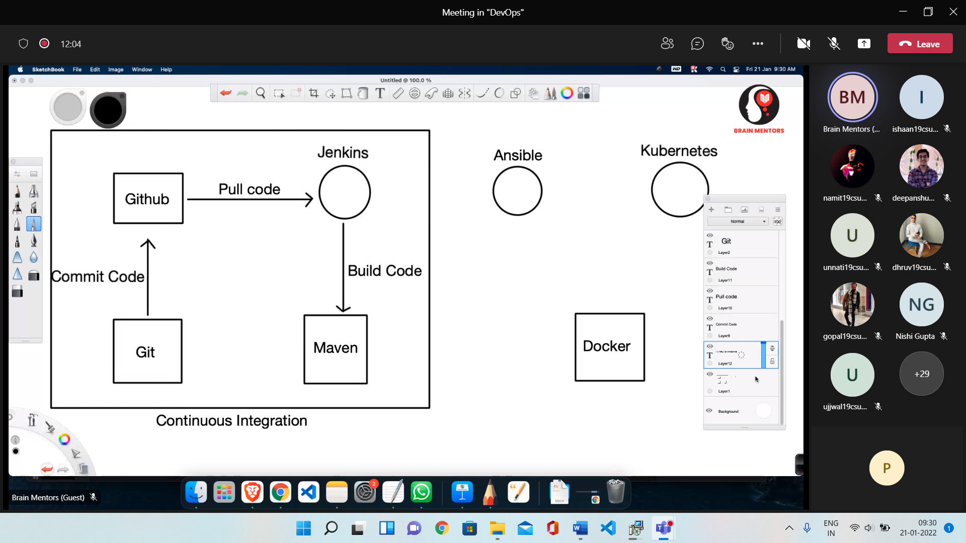

**Artifacts –** Some historical Object made by humans

Continuous Monitoring

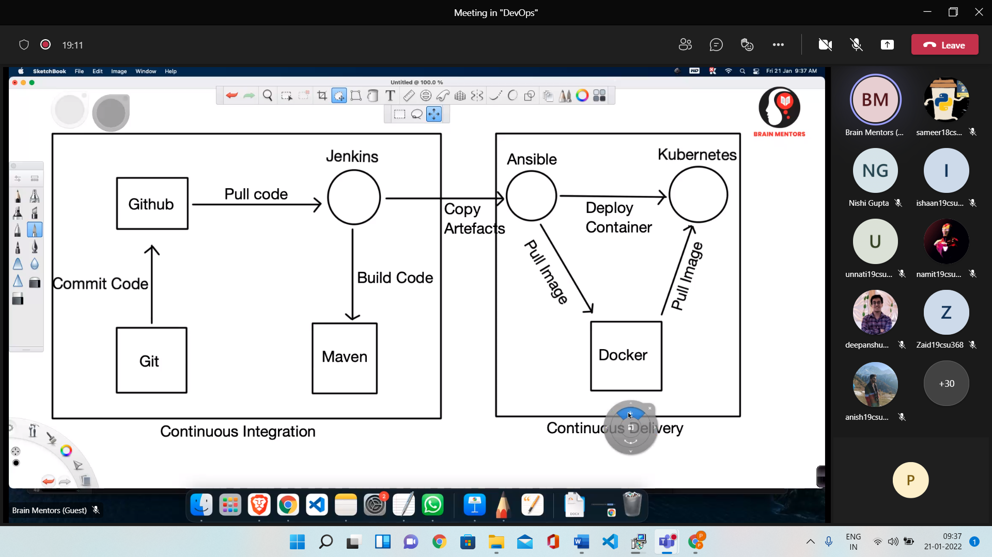

* After continuous delivery comes continuous deployment

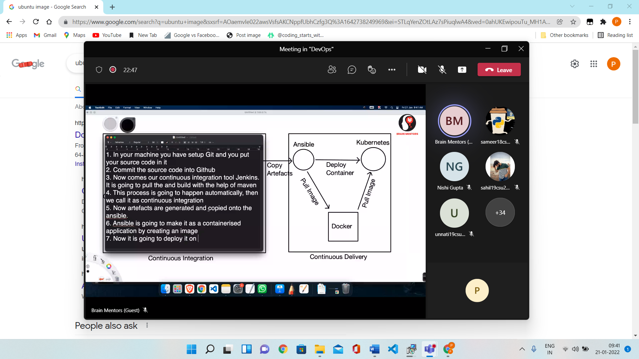

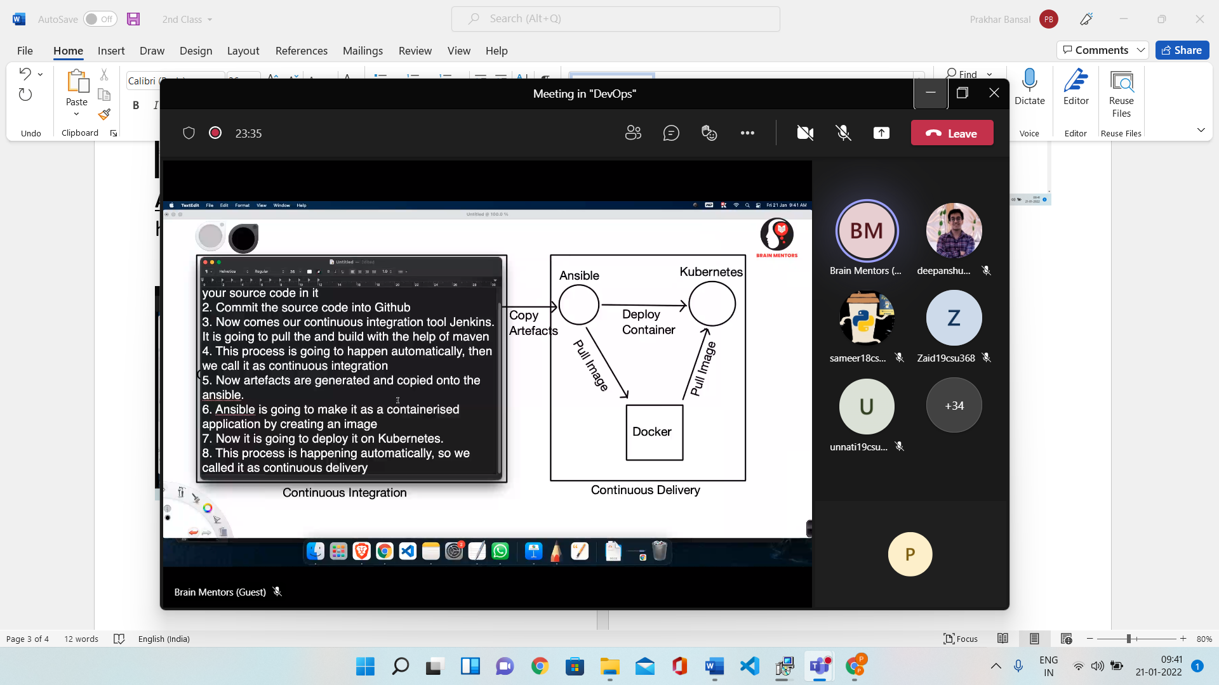

Source Code management / Version Control

1. Centralised Version control System
   1. There is a central repository
   2. It is not available directly
   3. Always need to connect with network
2. Distributed Version control System
   1. Every contributor has their own copy of repo
   2. Not needed any Internet Connection
   3. We have local copy in our local machine
3. Jenkins
   1. It integrates all the Devops stages with the help of plugins (more than 2000 plugins)
   2. Few common plugins are
      1. Git
      2. Amazon EC2
      3. Maven

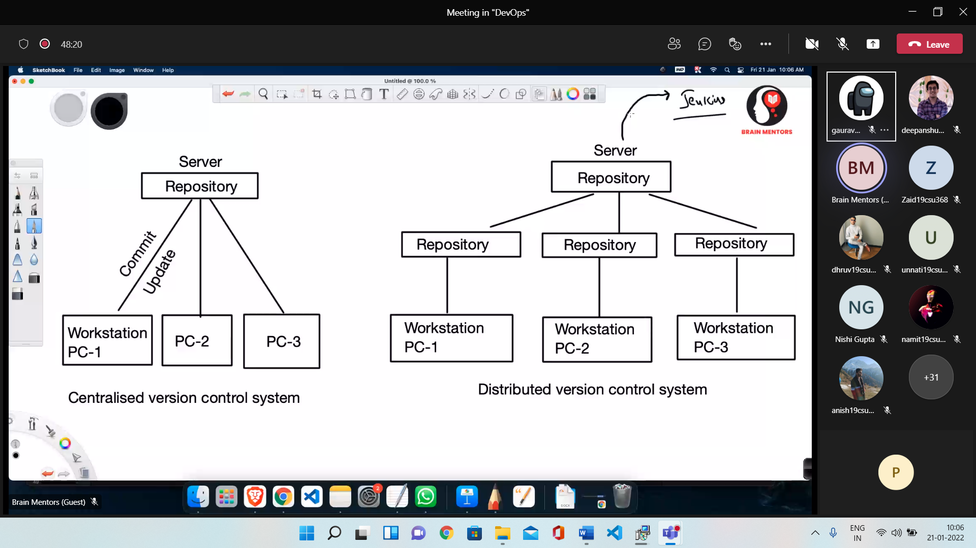

1. Jenkins Distributed Architecture
   1. Jenkins Master
   2. Jenkins Slave

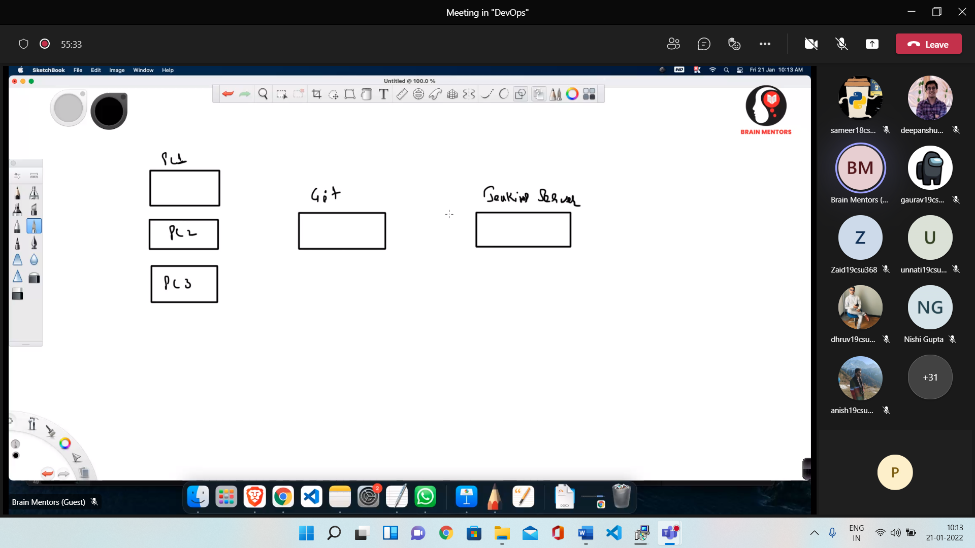

**CI/CD Pipeline**

* Automates the process of software delivery
* CI – Continuous Integration
* CD – Continuous Delivery
* CD – Continuous Deployment

**Stages of CI/CD Pipeline**

* Source
* Build
* Test
* Deploy

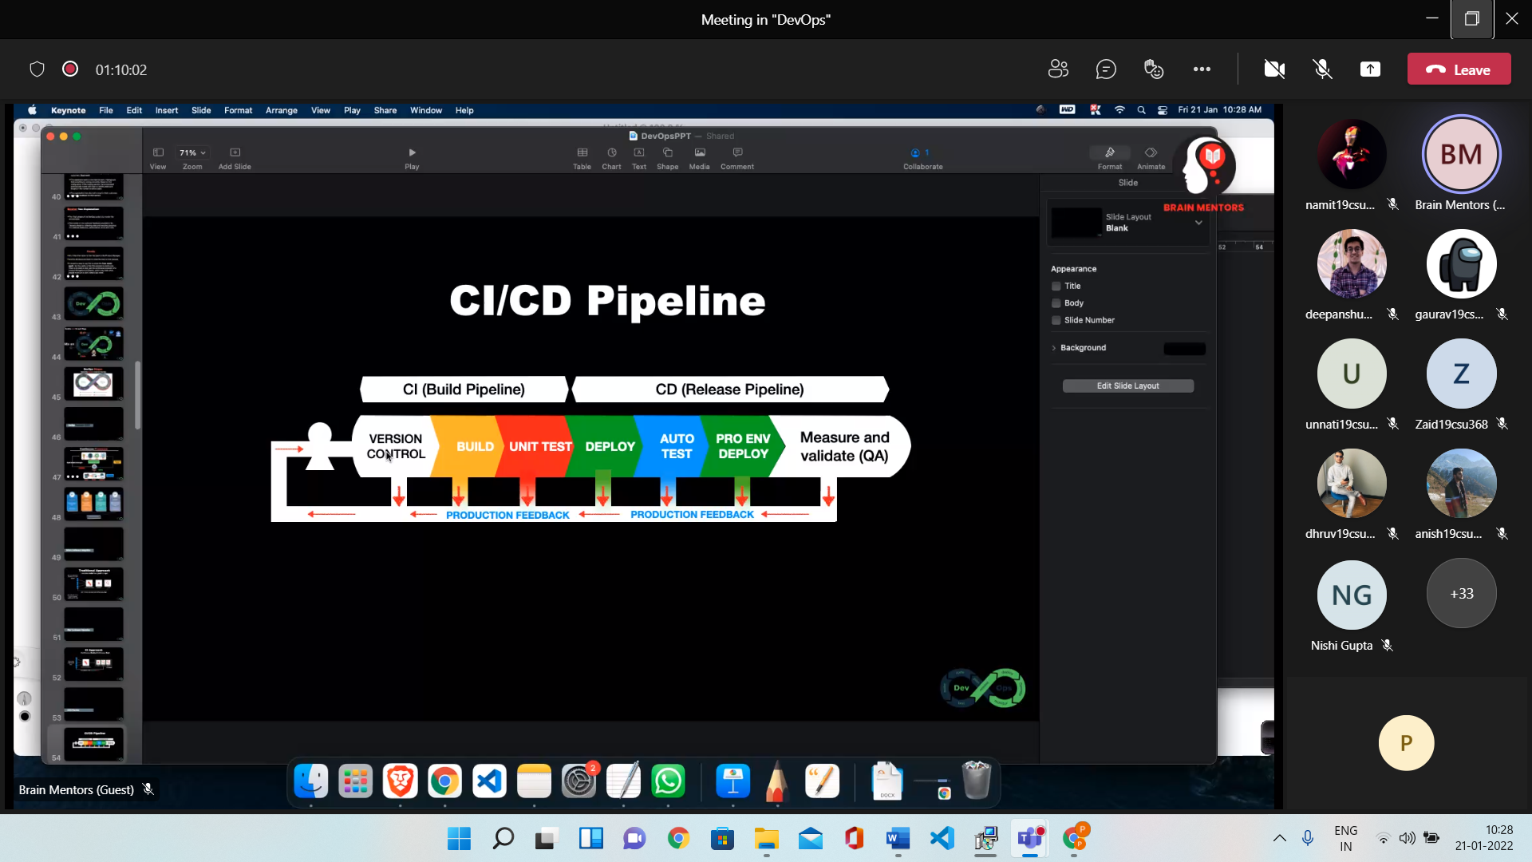

**Maven**

* .jar – Container for Desktop app
* .war – For web apps
* Before ANT was used

